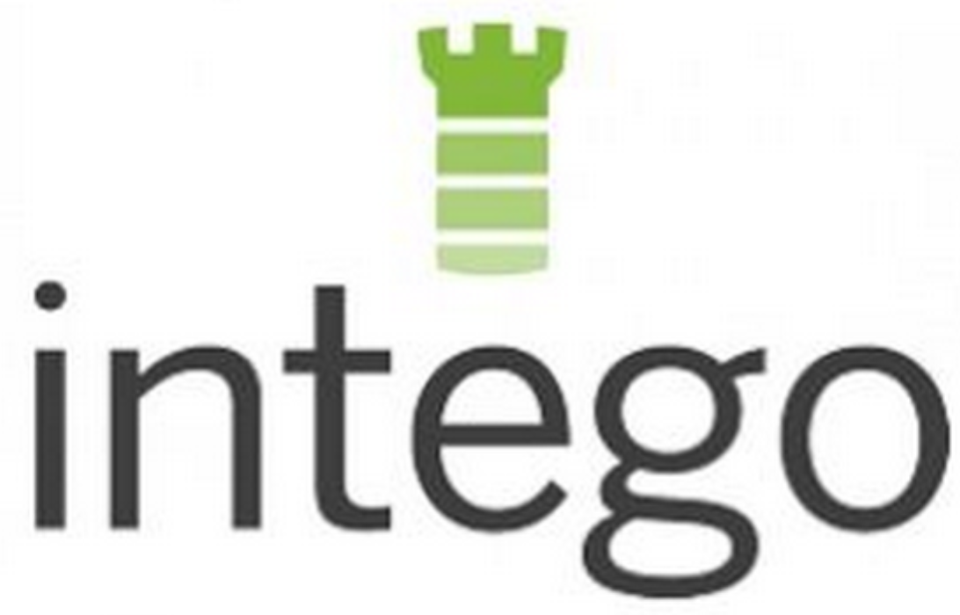

FOR MORE INFORMATION:
Cecilia Davis
562-889-2553
intego@zebrapartners.net

INTEGO FLEXTIVITY^{tm} 1.5 SIMPLIFIES SECURITY AND
PRODUCTIVITY MANAGEMENT FOR SMALL BUSINESSES

New Updates Improve Multiple Device Management,
Internet Security, and Scanning Performance

SEATTLE, AUGUST 13, 2015 – Intego, the leading provider of security solutions for the Mac, today announced the availability of Flextivity 1.5, offering small and medium sized businesses (SMBs) new features that make managing security and productivity for multiple devices more efficient. According to the National Small Business Association, 40 percent of small business owners manage their own tech support and 39 percent handle their own online security without any outside help. Flextivity’s new updates help address this pain point, providing an easy-to-use solution that’s designed from the ground up for SMBs.

As the market’s first integrated cloud-based security and activity monitoring solution for Mac-based SMBs, Flextivity helps small businesses protect their network and gives them powerful insight into employee activity and productivity. The newest version, Flextivity 1.5, includes new features that make managing multiple devices more efficient:
- Bulk approval of devices: Administrators can authorize or decline multiple devices at once directly from the “New Devices Alert” section, streamlining device management.
- Improved application firewall rules: Unsigned apps, as well as printer and scanner apps, can be whitelisted for network access. Each device user can also allow or block unsigned apps on the network, taking the burden from administrators.
- IP address exception range: Administrators can use asterisks as wildcard characters in IP address exceptions, making it easier to block a set of IP addresses and reducing administrative overheads.
- Exclude Time Machine from Real Time Scanning: For improved scanning performance, Time Machine can now be excluded from Real Time Scanning.

“Small business owners know the importance of securing their businesses from Internet threats, but they often don’t have the time or resources to put the right security measures in place,” said Jeff Erwin, president and CEO, Intego. “Flextivity solves this problem with an integrated solution that any small business can easily deploy. The latest features make it even easier for SMBs to manage and secure their Macs from both Mac and Windows threats.”

Built and delivered in the cloud, Flextivity is a comprehensive suite of affordable security and monitoring tools that helps SMBs ensure their Macs are secured from the latest Internet threats. Flextivity also gives SMBs the ability to control which applications employees can access, as well as when they can access them. The solution also includes web content filtering features and customized time and location-based limits on Internet access to increase employee productivity.

Current Flextivity customers will receive the 1.5 updates automatically. Flextivity can be purchased for a monthly subscription as a fully integrated solution or as standalone products:
- Secure - Antivirus and firewall protection (starting at $3.50 per computer);
- Monitor - Detailed activity reporting, app and network usage control, enabling employers and employees to bring greater transparency to their daily work stream ($8.50 per computer);
- Complete - Fully integrated suite with both Secure and Monitor ($12 per computer).
Discounts are available for volume purchases, and unlike other solutions, there is no long-term contract or annual commitment. Flextivity is available in English, French, German, Japanese and Spanish.

Learn more about Flextivity at www.flextivity.com or follow us on Twitter: @flextivity.

About Intego
Intego is a Seattle based software company that has been designing award-winning solutions to protect and optimize Apple products for 17 years. Its focused experience allows the company to create software that not only works well, but is also elegant and intuitive - just like the Mac and iOS devices it protects and enhances. For more information, visit www.intego.com.

# # #

National Small Business Association, 2013 Small Business Technology Survey, http://www.nsba.biz/wp-content/uploads/2013/09/Technology-Survey-2013.pdf

